(This manual was updated on 8/19/2026. By Dr. Beznosko and Dr. Krivosheev)

Lab #8: Friction Forces
By: Dr. D. Beznosko, A. Iakovlev
(Lab outcomes: Analyze external data with Tracker. Use sensors data offline. Approximate peak value and error.)

Abstract
The Friction Forces is a Tracker-based assignment. The stationary body experiences static friction whereas a moving body experiences kinetic friction. Both the $μ_{static}$ and $μ_{kinetic}$ will be found in this experiment. Additionally, the Tracker is used as an analysis tool for external data.

Introduction
This experiment is from the Tracker series labs. The instructions provided will allow to measure the static and kinetic friction coefficient Hint – you can provide some background information on the science behind the friction, who studied it, why it is important (any practical uses), and any other relevant information. Can the friction coefficient be >1?
Additionally, Tracker is shown to be a versatile data analysis tool that can use external data that is not derived from actual tracking of the object in the video. Can you think of any uses of this feature in life outside of the physics lab?

Experimental Setup
The setup is shown in Figure 1 and consists of the aluminum track (Figure 1a), a mass placed on a wooden block (Figure 1b) that is attached to a force sensor (Figure 1c) by string. Do not copy this picture. Instead, create a schematic for your lab report.


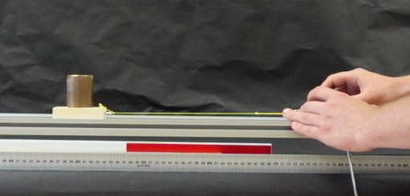
a)
c)
b)
Figure 1: The experimental setup schematic for the friction forces experiment. (a) aluminum track, (b) known mass on a wooden block, (c) force sensor pulled by hand.

A set of 5 different weights from 500 g to 1300 g with a 200 g increment was used in this lab. The weight of the wooden block could be taken from the Figure 2 and should be added to each of the 5 weights. Think about the error on this measurement of the block mass.

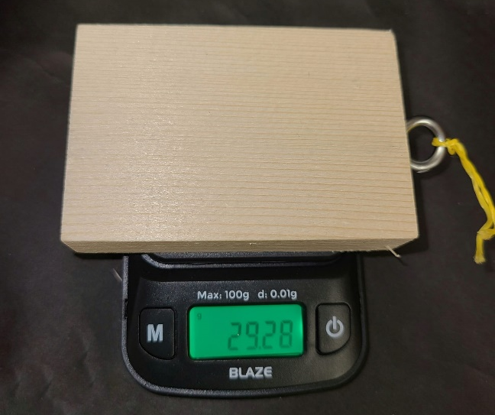
Figure 2: Wooden block (Figure 1b) weighed on the electronic scales.

Procedure:
Download the “Lab 8 Friction forces data.csv” or similarly named data file from D2L. Make sure it’s not a zip archive, unzip if needed. Open this file in Excel or a similar spreadsheet software. Data should look like shown in the Figure 3.

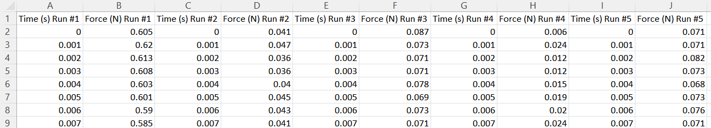
Figure 3. Force vs. Time data
The data in the file represents 5 data runs with different weights that were attached to a force sensor. For each weight, the Force vs Time data has been recorded using a force sensor. See the Table 1 for the information about the run number and the corresponding weight attached.
Note that each weight is a combination of individual weights of 500, 200 and 100 g. For example – 1300 g is 500 g +500 g +200 g + 100 g. The exact combination is shown in the Table 1. Each mass has a typical error of $±1.5$ g, use this in calculating a total error!
Table 1. Run numbers and corresponding additional weights. Remember to add the weight of the wooden block!
Run number | Weight used, g
Force (N) Run #1 | 500 g as a single mass
Force (N) Run #2 | 700 g as 500 g + 200 g
Force (N) Run #3 | 900 g as 500 g + 200 g + 200 g
Force (N) Run #4 | 1100 g as 500 g + 500 g + 100 g
Force (N) Run #5 | 1300 g as 500 g +500 g +200 g + 100 g

Start by plotting “Force (N) Run #1” “Time (s) Run #1” to see how the data looks like before attempting the analysis. Your result should look similar to that shown in Figure 4.
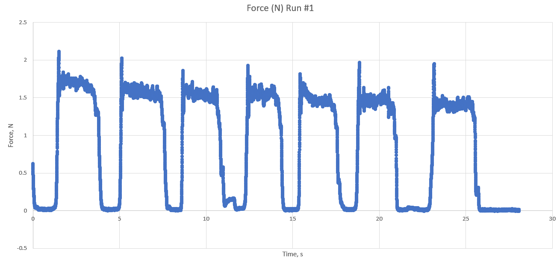
Figure 4. Force vs Time graph for the Run #1
Each repeating portion of the data represents several trials, when the same weight attached to a force sensor was pulled for a minimum of 5 times with about constant velocity.
If you zoom in the graph, you will see that each trial has a peak force value (Figure 4a) and a region where force is more consistent (Figure 4b).
For the analysis, you would need to calculate the average and standard deviation values for the peak force and for the regions of constant force for at least 5 different trials for each weight value. It is possible to do this in Excel or similar software. However, locating maximum value of the force in the raw data might be a challenging task because the Excel plot doesn’t allow you to select several points of interest and get statistical information about the selected data directly from the plot. Thus, we will use the Tracker instead for convenience in analyzing data. Close Excel, DO NOT SAVE when a program offers to do so. We will not use anything from Excel in this lab, so don’t put that in lab report either.

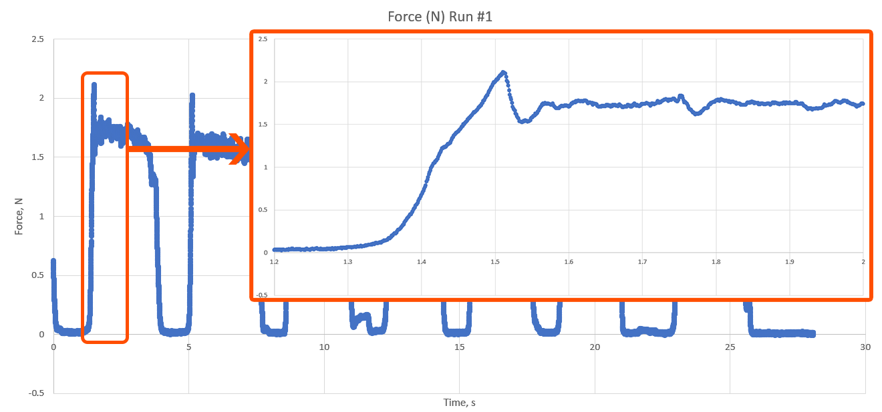
b)

a)

Figure 5. Zoomed-in region. (a) peak value of the static frictional force, (b) kinetic frictional force acting
for a few seconds.
Switching to using Tracker only:
Your task is to import this data from Excel into Tracker. Note that file is the comma separated values (csv) and not an xls/xlsx format. You can save other data as csv using ‘save as’ in Excel in the future but for this lab it’s already done for you.
Follow these steps to import the csv formatted data into the Tracker:
(note that figures here are not numbered, don’t do that in your report!)
1. Open Tracker app, click on “Data Tool (Analyze)” from the View tab. (No video is used!)
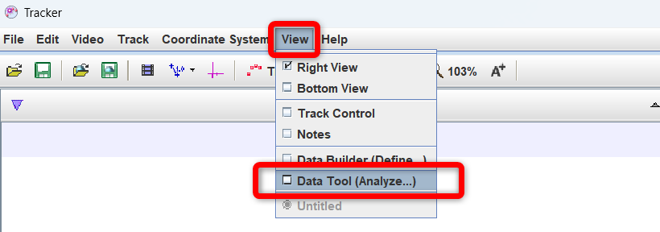

2. From the Data Tool window, select “File” – “Open…”.
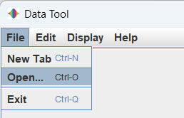

3. Select the data file downloaded from D2L and click “Open” (the file name can differ from the one shown!).
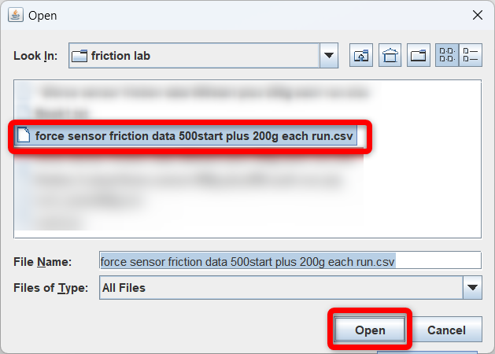

4. You will see all data imported from .csv file into Data Tool. Now you need to organize your workspace so that everything is visible. You can drag the vertical line that separates the plot and data table to the left in order to see all columns on your screen.

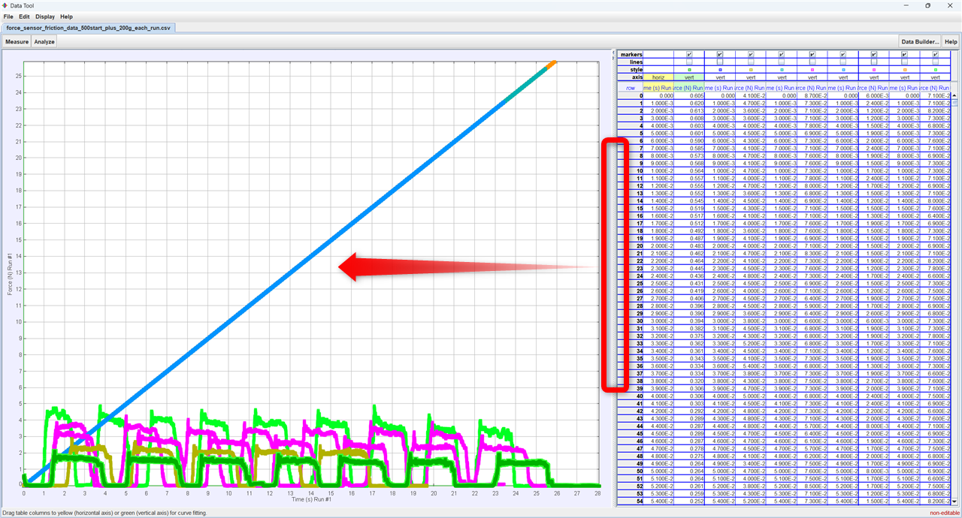
You can move the border between the plot and data to increase the table's visibility.
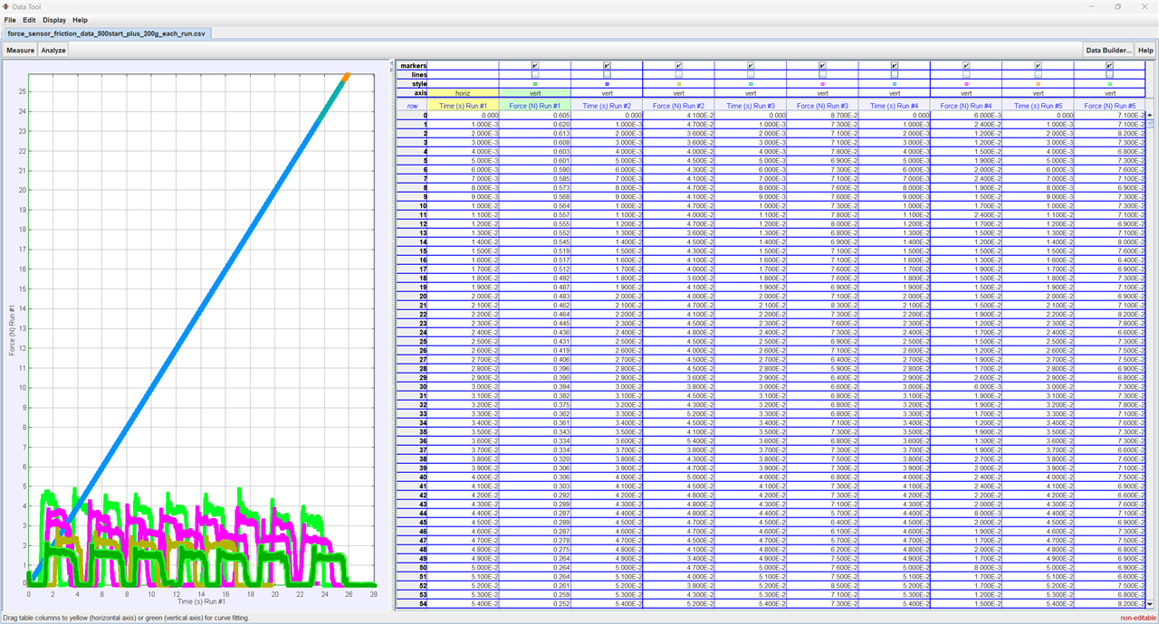

5. Since all data is plotted all at once, you need to hide all the data from the graph except the one that you need to analyze (i.e., “Force (N) Run #1” vs “Time (s) Run #1”). You can do that by clicking checkboxes on the top of the data table. Uncheck all checkboxes except “Force (N) Run #1” (“Time (s) Run #1” Time would have no checkboxes, should be selected as x-axis).
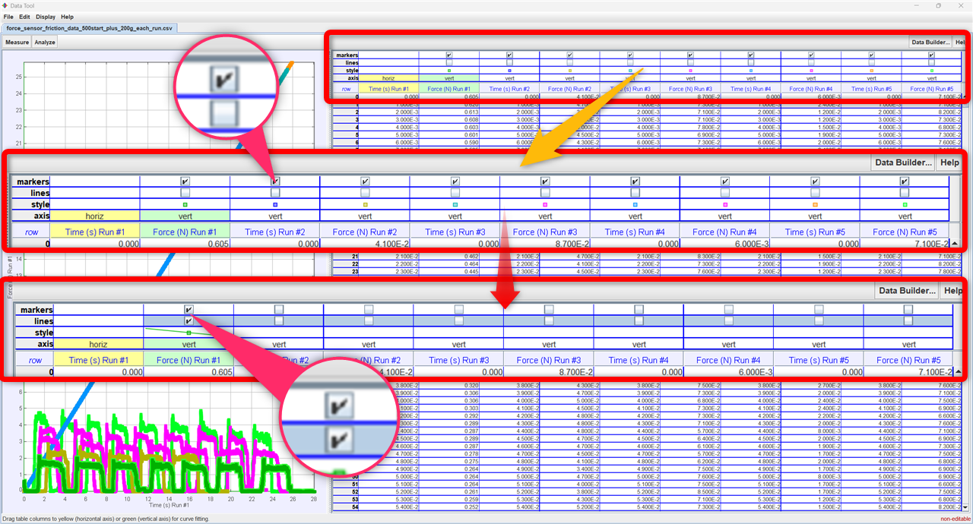

6. You should see the following result in your plot area (note multiple peaks and valleys! You will need to measure at least 5 of them)

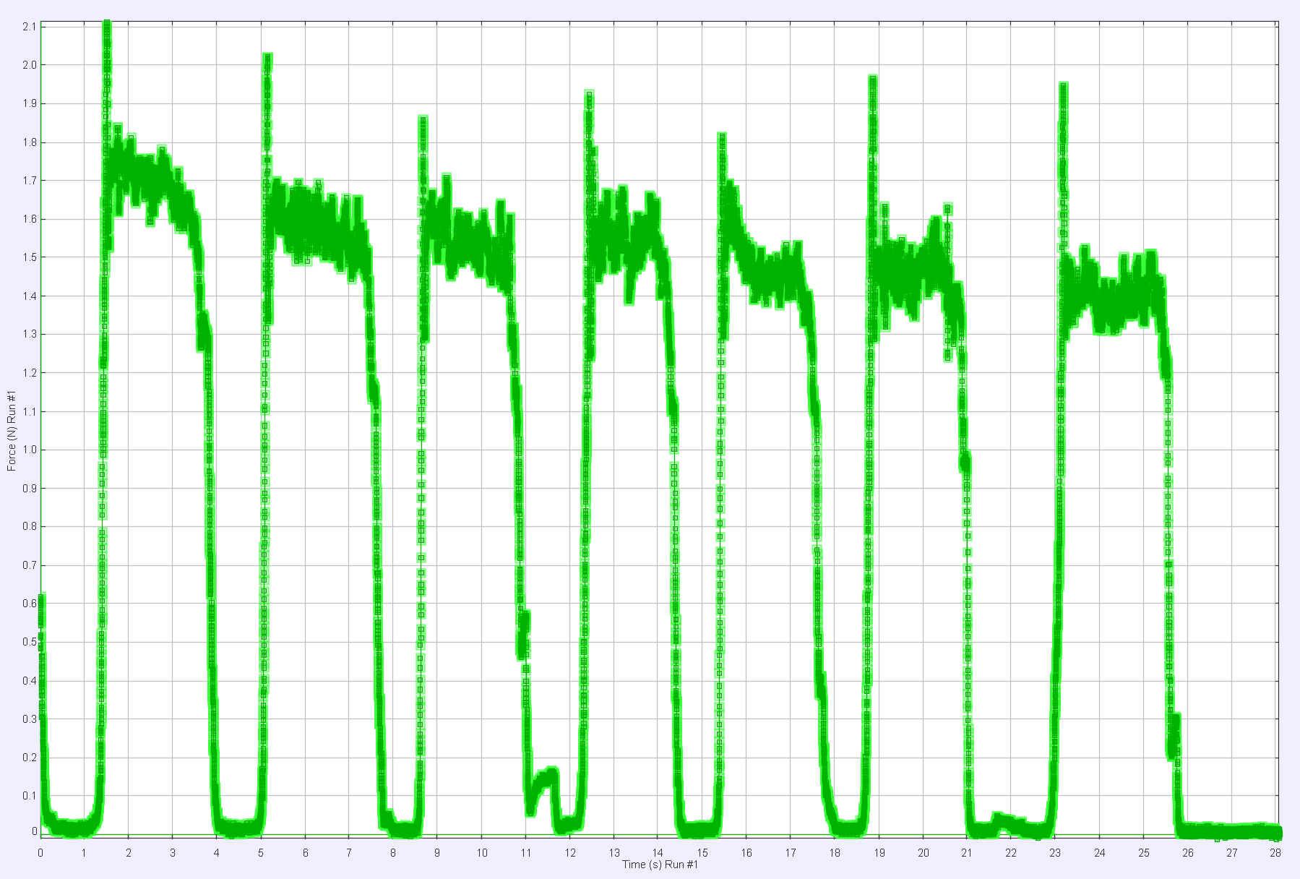

7. To zoom-in, you need to click and hold the right button of your mouse and draw a rectangular selection around the area of interest in the plot area, release the right mouse button and choose “Zoom In” in the popup context menu.

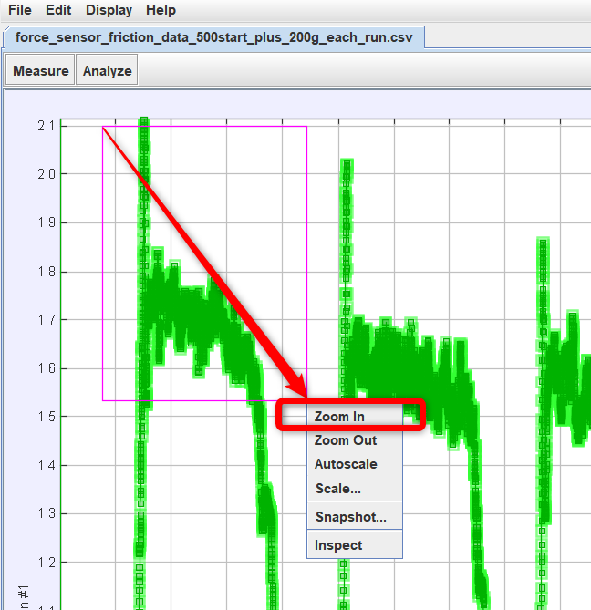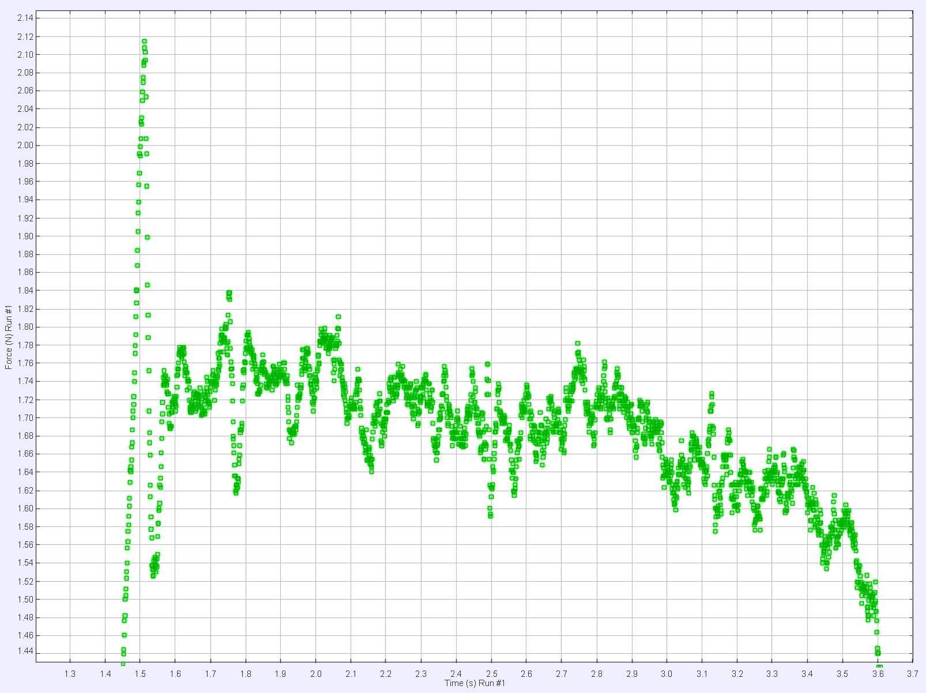

To zoom out, right click on the plot area and choose “Autoscale”.
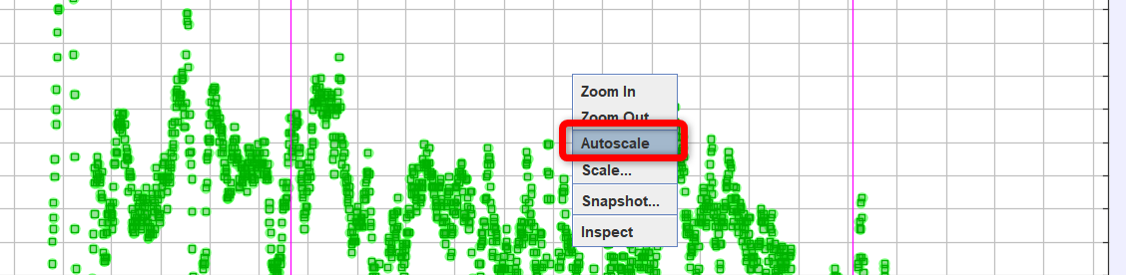

8. If you want to adjust the range of the horizontal axis (that is, move the plot right or left), you need to move our mouse directly to the line separating the plot area and the numbered axis, click and drag to the left or right. Here is an example:

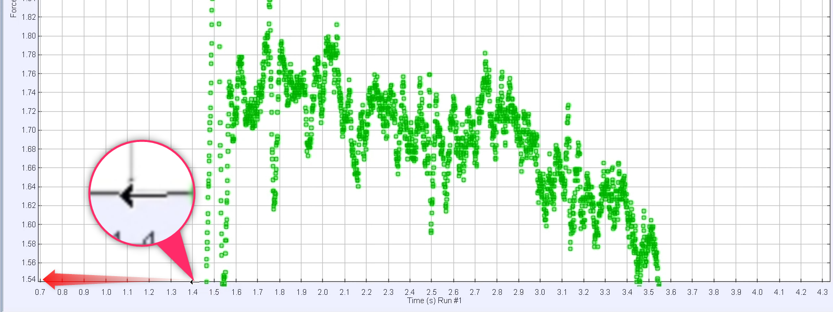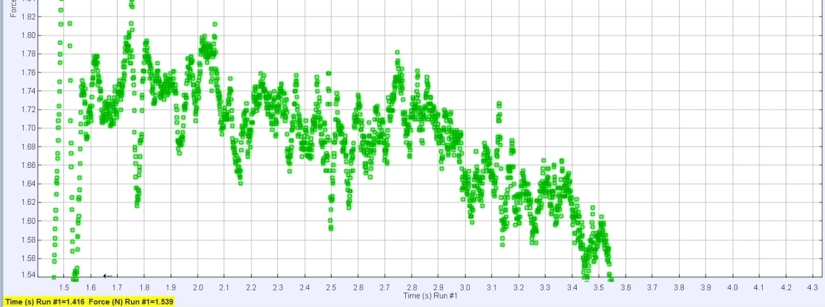

The same technique works for the left, right, and middle of the axis (for both vertical and horizontal ones). The middle arrow pans over the plot area.
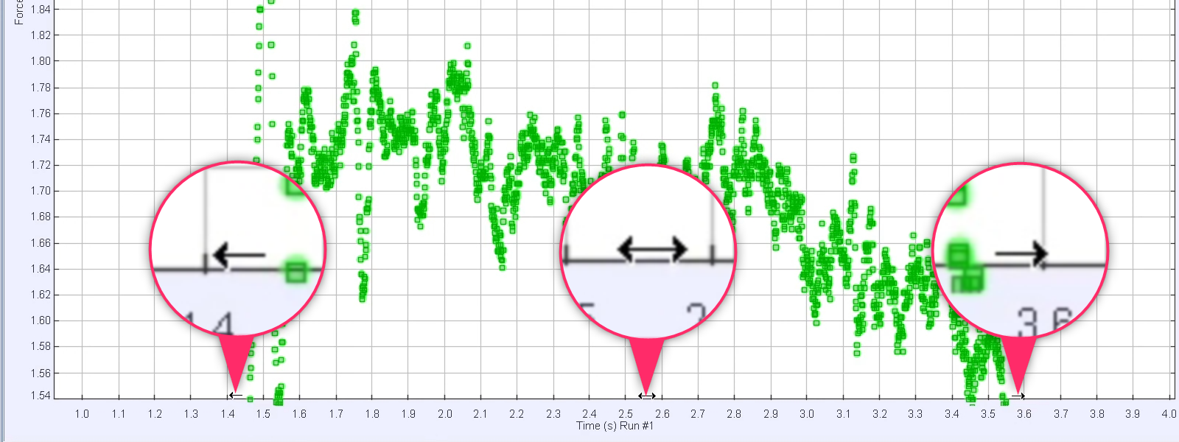

9. Click on “Analyze” tab and select “Statistics”. Now statistics of any highlighted points in the plot will be displayed on the top of the data table.
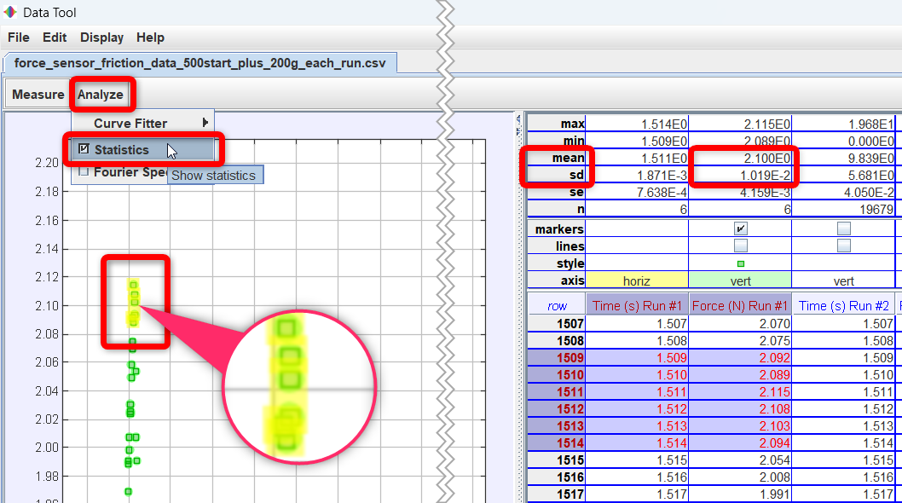
Statistics for the highlighted points
Highlighted points

10. You should select 4-6 points closest to the peak value to measure the static frictional force. Record “mean” and “sd” (standard deviation) values. Repeat this for the 4 more best-looking peaks in the same run. Find the average of all the means and all sd values (using Excel perhaps?) – this will be your value of the static friction force and its systematic error. Find the stdev of the means – this is the statistical error. (see the convenience table below). Combine errors in quadrature.
11. To measure kinetic frictional force, you need to select a region that follows the static frictional force peak value. Select at least 10 points or more as long as they are fairly horizontal. Note the mean and the sd (the error, standard deviation).
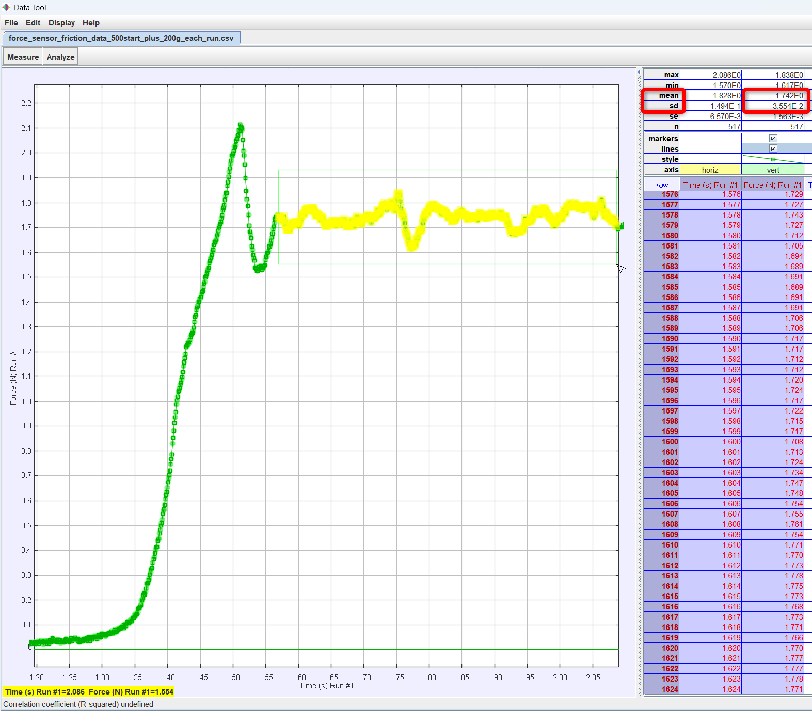

12. Measure this kinetic frictional force for at least 4 more different trials within one run (one run corresponds to a single weight value). Average the measured means and standard deviation (sd) values for all 5 trials using excel – this gives you experimental value for kinetic friction and its systematic error. The stdev of all means is the statistical error. Combine errors in quadrature.

For convenience, you can organize this data in a series of tables, one per each run. You should include all these tables in the Appendix. The ‘Average for the Run’ value of the force that you will use later in the analysis. The run’s average of the sd is the statistical error. Stdev For the Run is done only for the means, and it’s the systematic error. Remember to combine errors in quadrature – separately for static and kinetic friction force, of course.

 | Run 1
 | Static friction force, N |  | Kinetic friction force, N
Peak # | Mean | sd | Mean | sd
1
2
3
4
5
Average for the Run
Stdev for the Run |  | Nothing here |  | Nothing here

Hint: Below is the example of the 5 parts to analyze that are chosen within the same run.
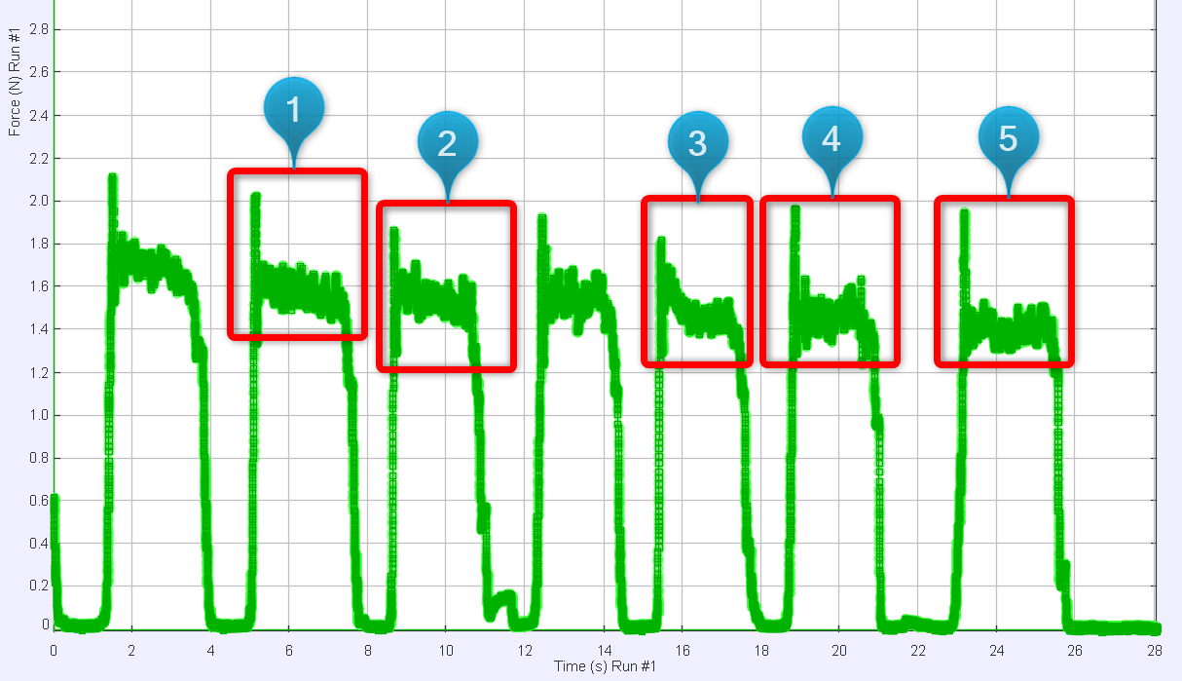
Please note that you need to decide what data is good by yourself!
Here is an example of a good and bad data:
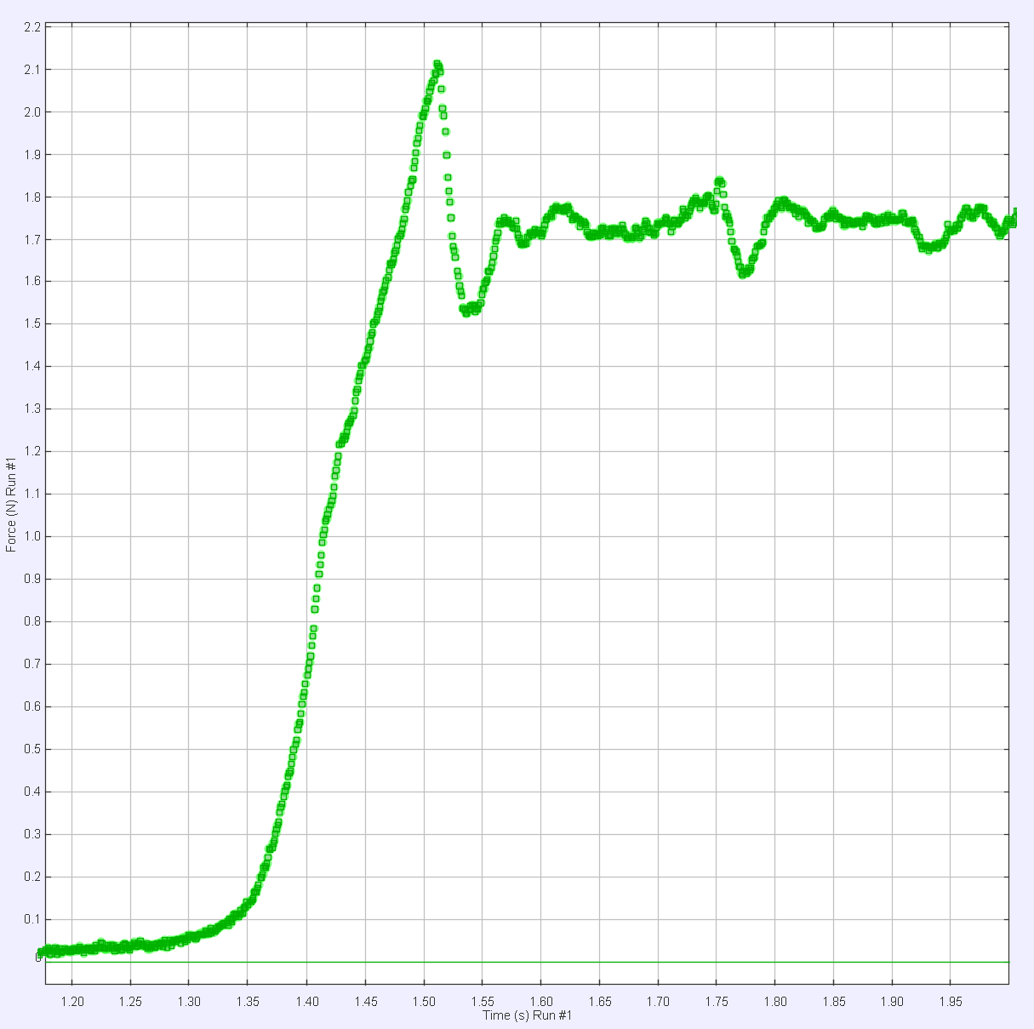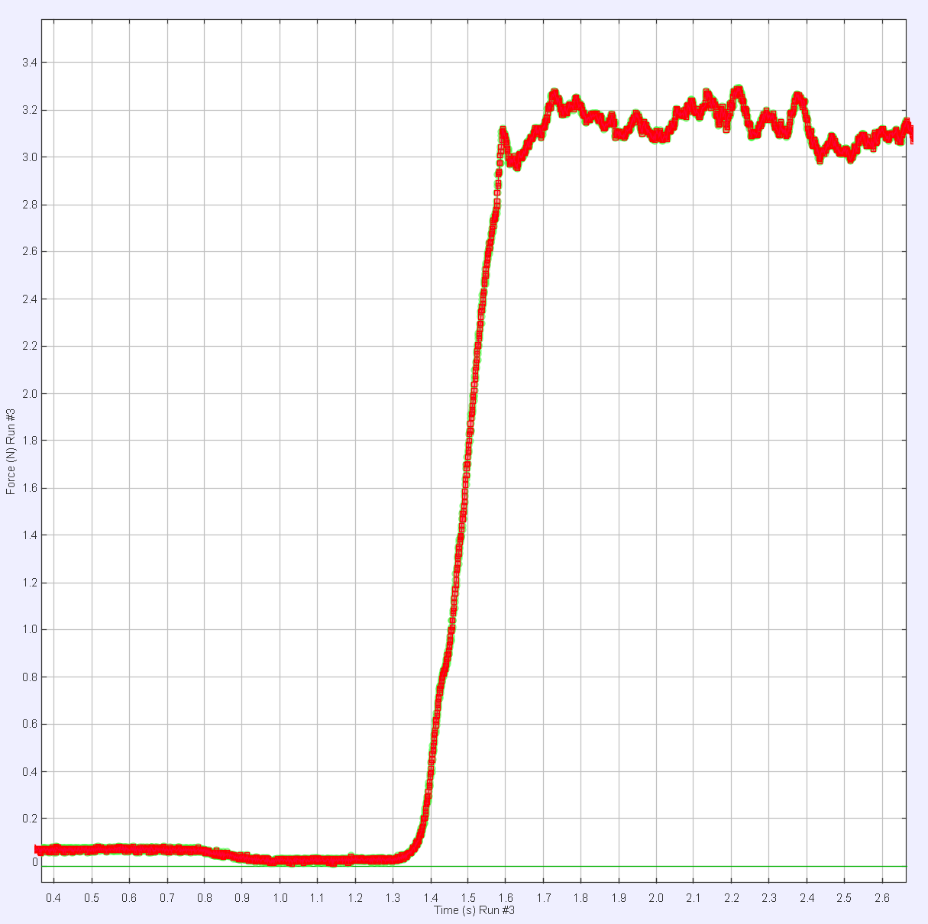
Bad data, peak static force is not visible
Good data, peak static force visible
13. To show a different run on the plot, you need to select the corresponding Y and X axes in the graph by clicking on the label of the Y axis and selecting a different run (e.g. “Force (N) Run #2”). Do the same to change X axis to the corresponding Time for the run# selected (if you selected “Force (N) Run #2”, the corresponding X axis for the time will be “Time (s) Run #2”).
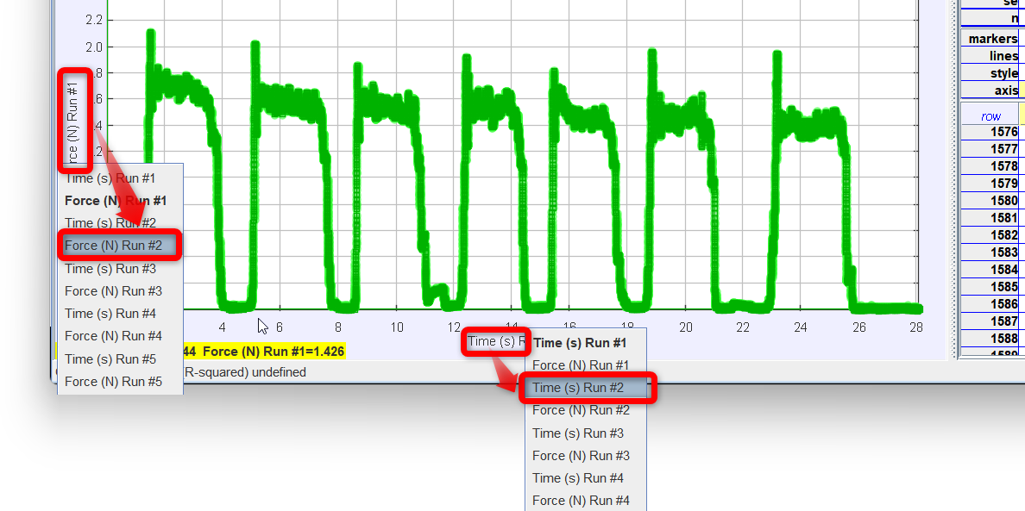

When you select data for a different run, you might need to uncheck all checkboxes for the other runs to hide them from the graph. Here is an example for the “Run #2”.
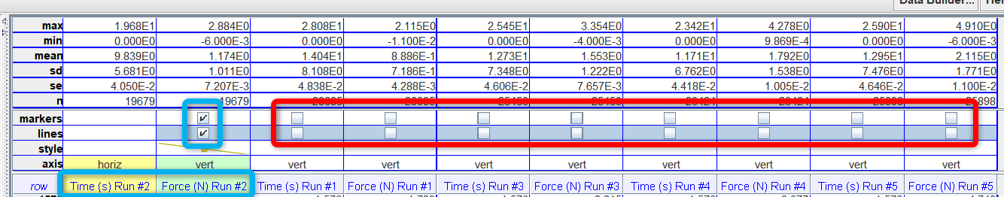
Run 2 is checked
The rest are unchecked

14. Collect the final values for force data for static frictional force and kinetic frictional force for all runs. You are welcome to organize this table in a different way. This should be shown in the experimental data section with an explanation.
Run 1 |  |  |  | … | Run 5
Static friction |  | Kinetic friction |  | … | Static friction |  | Kinetic friction
Force, N | Error, N | Force, N | Error, N | … | Force, N | Error, N | Force, N | Error, N

Theory
When a force is applied to any object that is at rest on a real surface, the object will not move until certain threshold amount of force is reached. This force is called a static frictional force and could be described using equation 1:
$${F_{s}=μ}_{s}F_{N} (1)$$
where $μ_{s}$ is the static friction coefficient, $F_{N}$ is the normal force. What is the equation for the normal force on a horizontal surface?
As an object starts to move, less force is needed to keep it moving. As long as the acceleration is 0 and the motion is uniform, the applied force equals the kinetic friction force (show the full equation using Newton’s 2nd law and set $a$ to 0 to derive this statement). For the uniform motion case, this force could be simply described using equation 2.
$${F_{k}=μ}_{k}F_{N} (2)$$
where $μ_{k}$ is the static friction coefficient. Since static friction is normally higher than kinetic, a sharp drop in force value needed to keep object moving uniformly after it starts moving is observed in the experimental data.

Analysis
Plot in Excel the force of static friction vs normal force for all 5 runs (each run is a different normal force. Use values from the experimental data section). Errors for the force are the vertical error bars, the errors for the normal force are the horizontal (these might be very small to be visible, mention that in the plot description somewhere). What does the slope of the best fit line represent? Think equation 1. Do the linear regression for the error of the slope. Remember to find $χ^{2}$!
Do the same for the force of kinetic friction. Do the linear regression for the error.
Show the static and kinetic friction coefficients with their errors separately. This is your result. ($±error!$)..

Conclusion
Comment on the values of the friction coefficients you measured – which one is larger, should it be this way? Compare them with the known values for different material pairs. In this experiment, dry wood block slides on an aluminum track. There are many websites online that may give you some insights about static friction coefficient for different materials. Do they match well with your result? Do the % discrepancy with the closest you could find. Are some values you found above and some below the predicted values or are all above/below? What could be the reasons for that? Any comments and possible improvement suggestions?

